COAL – Home tasks – 24k0880

Task 1: Print hello world
include irvine32.inc
.data
text BYTE "Hello world!"
.code
main PROC
mov edx, offset text call WriteString
main endP
end main

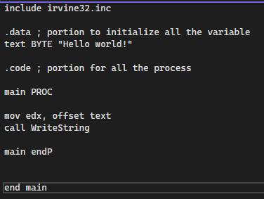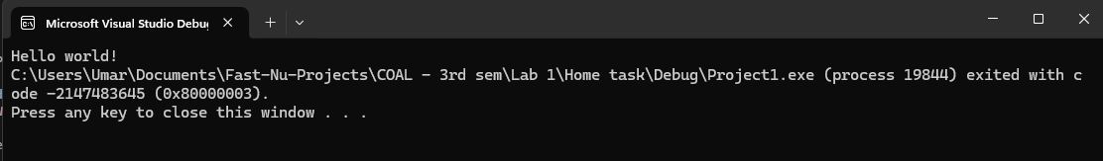

Task 2:
INCLUDE Irvine32.inc

.data
msg1 BYTE "Experiment: Dumping registers after loading values", 0

.code
main PROC

mov edx, OFFSET msg1
call WriteString
call Crlf

mov eax, 12345678h
mov ebx, 87654321h
mov ecx, 11111111h
mov edx, 22222222h

mov esi, 33333333h
mov edi, 44444444h
mov ebp, 55555555h

call DumpRegs

mov eax, 0AAAAAAAh
mov ebx, 0BBBBBBBh
mov ecx, 0CCCCCCCh
mov edx, 0DDDDDDDh
mov esi, 0EEEEEEEh
mov edi, 0FFFFFFFh
mov ebp, 1234ABCDh

call DumpRegs

exit
main ENDP
END main
